This skills check covers pre-requisite material needed for the first unit of the course, areas and volumes

- Identifying Bounded Regions
- Shade the region bounded by the following curves:
- Shade the region bounded by the following curves:
- Shade the region bounded by the following curves:
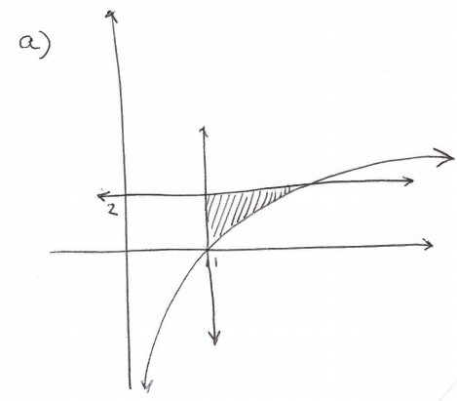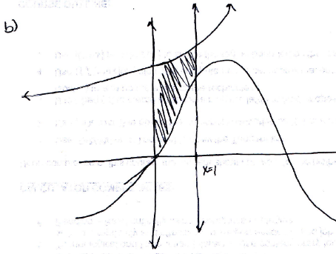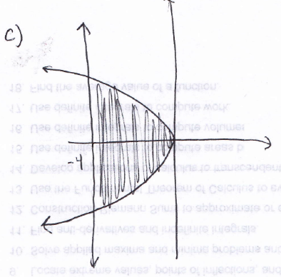

- Finding Points of Intersection
- Find the points of intersection of the curves:
Therefore the points of intersection are:

- Find the points of intersection of the curves:
Therefore the point of intersection is:
- Find the points of intersection of the curves:
Since both sides of the equations were squared during the solving process we must check for extraneous solutions. If we check both potential solutions we find that is an extraneous solution!
Therefore the only point of intersection is:

- Definite Integrals for Rotations
- Evaluate the definite integral:
- Evaluate the definite integral:
- Evaluate the definite integral:

- U-Substitutions with Definite Integrals
- Use a u-substitution to evaluate the definite integral:
Let and thus .
Our limits of integration become: .

- Use a u-substitution to evaluate the definite integral:
Let and thus .
Our limits of integration become: .

- Use a u-substitution to evaluate the definite integral:
Let and thus .
Our limits of integration become:

- Solving Literal Equations
- Solve the equation for x:
- Solve the equation for x:

- Solve the equation for x:

